Grades Primary - 3 Supply List

- 1 school sized backpack (please label)
- Lunch bag (please label)
- 1 package of crayons
- 1 package of markers
- 1 package of colour pencils
- 2 packages of pencils
- 1 pair scissors

- 2 glue sticks
- 2 white erasers
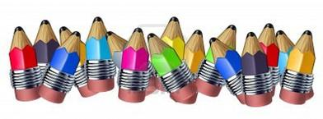
- 1 pencil case
- 1 pair of headphones

Note: indoor sneakers are expected to be worn in gym class. Grade primary students should also keep a change of clothing at school.
***Please bring all supplies with your child’s name on it on the first day of school***

