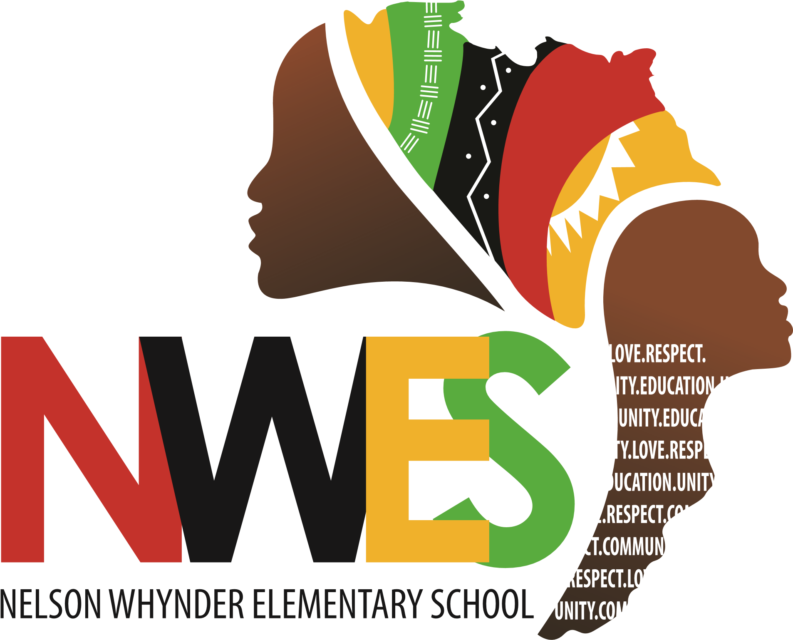
Nelson Whynder Elementary
October Newsletter

IMPORTANT DATES:
- October is Mi'kmaq History Month
- October is Canadian Library Month
- October 1: Treaty Day
- October 7: Bus Evacuation/ Safety Practice Day
- October 8: Home & School Meeting
- October 12: Thanksgiving - No classes PP-12
- October 16-School Author Visit: Keenan Jones
- October 19-Picture Day
- October 19-23: School Bus Safety Week
- October 23: NSTU Conference Day - No classes PP-12

Greetings NWES Families,
As we begin October, thank you to our students, staff, families, and community for such a positive start to the school year. Our students are settling into routines, building relationships, and demonstrating what it means to learn, grow, and lead together.
October is Mi’kmaw History Month, an important opportunity to deepen our understanding of Mi’kmaw history, culture, language, traditions, and the Peace and Friendship Treaties. Throughout the month, students will engage in learning that honours Mi’kmaw voices and strengthens our understanding of our shared responsibilities as Treaty People.
At NWES, we remain committed to Community First, Excellence Always. Teachers will continue using literacy and mathematics data to identify strengths, areas for growth, and next steps for student learning.
We will also continue reinforcing our schoolwide expectations through the Nguzo Saba, encouraging students to live these principles through their words, choices, learning, and relationships.
Thank you, families, for your continued trust, partnership, and support. We look forward to another wonderful month of learning and growing together.
Warm regards,
April Desmond

NWES Family Reminder – Arrival and Dismissal Times

Dear Families,

This is a friendly reminder of our school’s arrival and dismissal schedule:

Earliest Student Drop-Off: 8:10 a.m.
Please do not drop off students before 8:10 a.m., as supervision is not available before that time.

Students Enter the School: 8:15 a.m.
Students should enter the building at 8:15 a.m. This helps ensure that instruction begins on time and allows students to transition directly into learning without losing instructional time.

Dismissal: 2:30 p.m.

Thank you for helping us maintain a safe environment for all students by following these arrival and dismissal times.



October 1 is Treaty Day
Treaty Day is an opportunity to learn, reflect and deepen our understanding of the historic and ongoing relationships between Mi’kmaq and non-Mi’kmaq people in Nova Scotia.
Treaties are not simply part of our past. They are living agreements that continue to shape our shared responsibilities today. In schools, Treaty Day provides an important opportunity to help students understand Mi’kmaq history, culture, rights and perspectives, while exploring what it means to live together in a spirit of respect, partnership and reciprocity.
By continuing to learn about the Treaties and our responsibilities within them, we help build stronger relationships and contribute to the ongoing work of reconciliation.

October is Mi'kmaq History Month
Each October, Mi'kmaq History Month provides an opportunity to deepen our understanding of Mi'kmaq culture, history, language and traditions, while recognizing the important contributions of Mi'kmaq people past and present.

Across our schools, students and staff may mark the month through learning, storytelling, art, community connections and cultural experiences that bring Mi'kmaq perspectives into the classroom and school community.
As we learn together, Mi'kmaq History Month reminds us of the importance of listening, building relationships and continuing our shared commitment to truth and reconciliation.
Learn more about Mi'kmaq History Month here.

Fire Prevention Week: October 4-10

Halifax Regional Fire & Emergency is inviting families to take part in Fire Prevention Week, October 4–10. Visit halifax.ca/fpw to complete an online fire safety quiz. Want to win a Nintendo Switch, Apple products or LEGO sets? Participants who score 100% will be entered into a draw for a prize in their age category.

This year’s theme, “Safe Charging is a Superpower,” focuses on the safe use and charging of rechargeable devices powered by lithium-ion batteries. These batteries power many everyday devices, including phones, tablets, laptops, e-bikes and power tools. If damaged or charged improperly, they can overheat and cause fires.
Visit halifax.ca/fpw for contest details, videos and fire safety resources, and take a few minutes to test your smoke alarms and review your home fire escape plan.

October 19-23 is School Bus Safety Week
Every school day, thousands of HRCE students rely on the bus to get to and from school safely.
School Bus Safety Week is a chance to highlight the simple habits that help keep everyone safe — from waiting well back from the road, to following the driver’s instructions, to staying alert around stopped school buses.
With more than 33,000 HRCE students travelling on more than 400 buses each day, safety depends on all of us: students, families, drivers, schools and motorists.
This week is a good opportunity to review a few everyday reminders and help reinforce safe routines on the bus, at the stop and on the road.
Bus Stop Safety
- Be on time for the bus and please don’t run to/from the bus.
- Stand back off the road and don't push or shove when waiting at a stop.
- Always cross in front of the bus. Walk three metres (10 feet) in front of the bus to a point where you can see the driver and wait for the driver's signal to cross. Proceed to the centre of the road, STOP, LOOK & LISTEN and cross the road when it is safe.
- Never crawl under a school bus or cross the road behind the bus.
- Know the danger zones around the bus.
School Bus Safety
- Please respect and listen to the driver and avoid distracting them.
- Please keep noise levels to a minimum.
- Do not stand or move seats while the bus is in motion.
- Never put your hands, arms, feet or head out of the bus window.
- Ask the driver for permission before you open the bus windows.
- Do not throw anything inside the bus or out of the windows.
- Keep the aisle clear at all times when the bus is in motion.

Remember: In Nova Scotia, it's illegal to pass a school bus when its red lights are flashing and the stop arm is extended.
You can find out more information about riding the school bus in HRCE here.

October is Canadian Library Month

October is a chance to celebrate the important role libraries play in our schools — and the Library Support Specialists who bring those spaces to life.
Every day, our school libraries help students discover new interests, build literacy skills, find reliable information and, sometimes, simply find a welcoming place to spend some time. Our Library Support Specialists are an important part of making that happen.
Canadian Library Workers Day is recognized on the third Friday of October, followed by Canadian School Library Day on the fourth Monday. These are great opportunities to recognize the people who help make our libraries engaging, inclusive and supportive spaces for students.
Please join us in thanking our Library Support Specialists for all they do to support students, staff and school communities.
Consider adding a personal note about your LSS and the difference they make in your school.

Do you know how to raise a concern?

Did you know that there’s a protocol in place to help families contact schools or the HRCE office when you have concerns about your student’s education or well-being?

All concerns should first be shared with your child’s teacher.

If your concern is not resolved, you should then contact the principal.

If your concern remains unresolved, you can reach out to HRCE’s Family Navigators who can provide information about a wide range of supports and resources.

If your matter continues to be unresolved, you can then initiate a formal review process in which the matter will be investigated by the appropriate HRCE Directors.

The final step is for your concern to be passed on to the Regional Executive Director.

Click here to learn more. 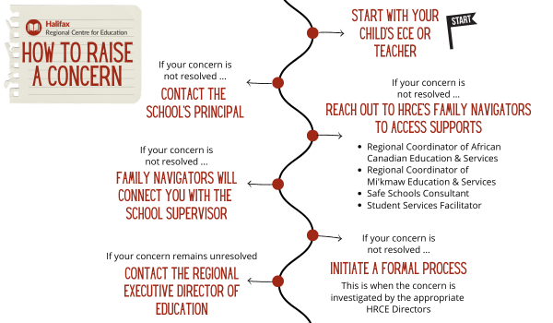

Power Outage Information for Families

As we move into the winter months, we want to share how decisions are made when a school experiences a power outage.

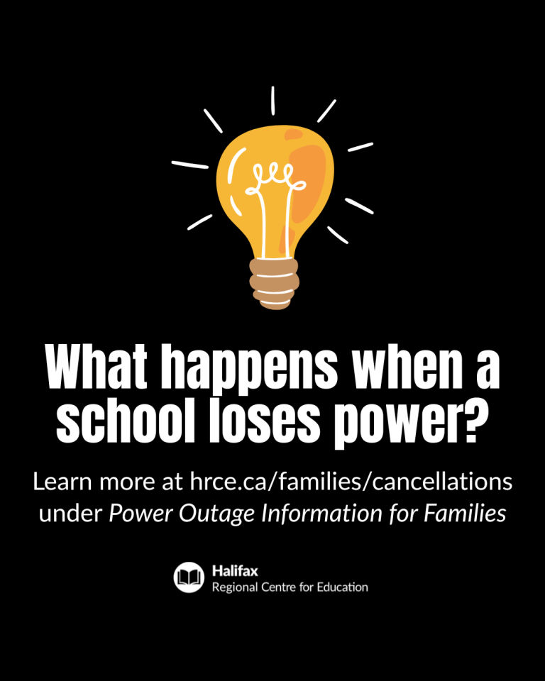
Our priority is always to keep schools open safely when possible. A power outage does not automatically mean classes are cancelled – even if it happens during the school day. The decision depends on when power is expected to be restored.

Here’s what happens:

When a school loses power, HRCE's Operations Team contacts Nova Scotia Power to gather available details on the cause and an estimated restoration time.

Once we have this information, we consider:

Before school starts: Have buses begun their routes? If so, we wait until students arrive before making a decision. If classes are cancelled, elementary families will be contacted before dismissal.

During the school day: How close is dismissal? What is the temperature in the building? Does the school rely on power for water or septic systems? These factors, among others, help us decide whether to stay open or close. Often, power returns faster than we could safely send students home.

If classes are cancelled:

HRCE will notify families by email and text.

Families of elementary students will also receive a phone call before dismissal.

Deciding to close schools during a power outage is never simple, but safety is always our top priority. We understand that cancellations can be inconvenient, and our goal is to keep students learning in class whenever possible.

More information about school cancellations for any reason can be found here.

Picture Day at Nelson Whynder Elementary School will take place on Monday, October 19, 2026, Students are encouraged to come ready with their best smiles! We look forward to capturing wonderful memories of our students.

Growing independence doesn't have to start with a smartphone
As children get older, parents naturally want to give them more independence, such as walking to the park, playing at a friend's house, staying home for a short time, or getting to activities on their own. A smartphone can seem like the obvious way to make this possible, but it isn't the only option.
There are lots of ways families can give children more freedom while keeping communication simple and age-appropriate:
- Long-range walkie-talkies: A simple way for kids to check in while playing in the neighbourhood or exploring outdoors, without access to the internet or social media.
- A home phone: Allows children to call friends, make plans or contact a parent when they're home alone.
- A kids' smartwatch: Some watches offer limited calling or messaging, without the apps, social media and internet access of a smartphone.
- A basic talk-and-text phone: When children eventually need a way to coordinate rides or activities, a simple phone can provide communication without introducing the distractions and social pressures of a smartphone.
The goal is to match the technology to what children actually need. A child who needs to call home doesn't necessarily need a device that also gives them access to social media, games and the internet.
Starting with a more limited device can give children time to develop the responsibility, judgment and independence they'll eventually need to manage a smartphone.
Explore more resources from Unplugged Canada and join thousands of Canadian families taking the Unplugged Canada Pledge to delay smartphones and support connected childhoods.

