**Nelson**

**Whynder**

**Elementary**

**March**

**2025**

**Newsletter**

**IMPORTANT**

**DATES:**

**●**

**March**

**7:**

**No**

**School**

**Elementary**

**and**

**Junior**

**High**

**Schools,**

**Assessment**

**&**

**Evaluation**

**Day**

**●**

**March**

**8:**

**International**

**Women’s**

**Day**

**●**

**March**

**10-14:**

**March**

**Break**

**-**

**No**

**School**

**●**

**March**

**21:**

**World**

**Down**

**Syndrome**

**Day**

**●**

**March**

**21:**

**International**

**Day**

**for**

**the**

**Elimination**

**of**

**Racial**

**Discrimination**

**●**

**March**

**31:**

**International**

**Transgender**

**Day**

**of**

**Visibility**

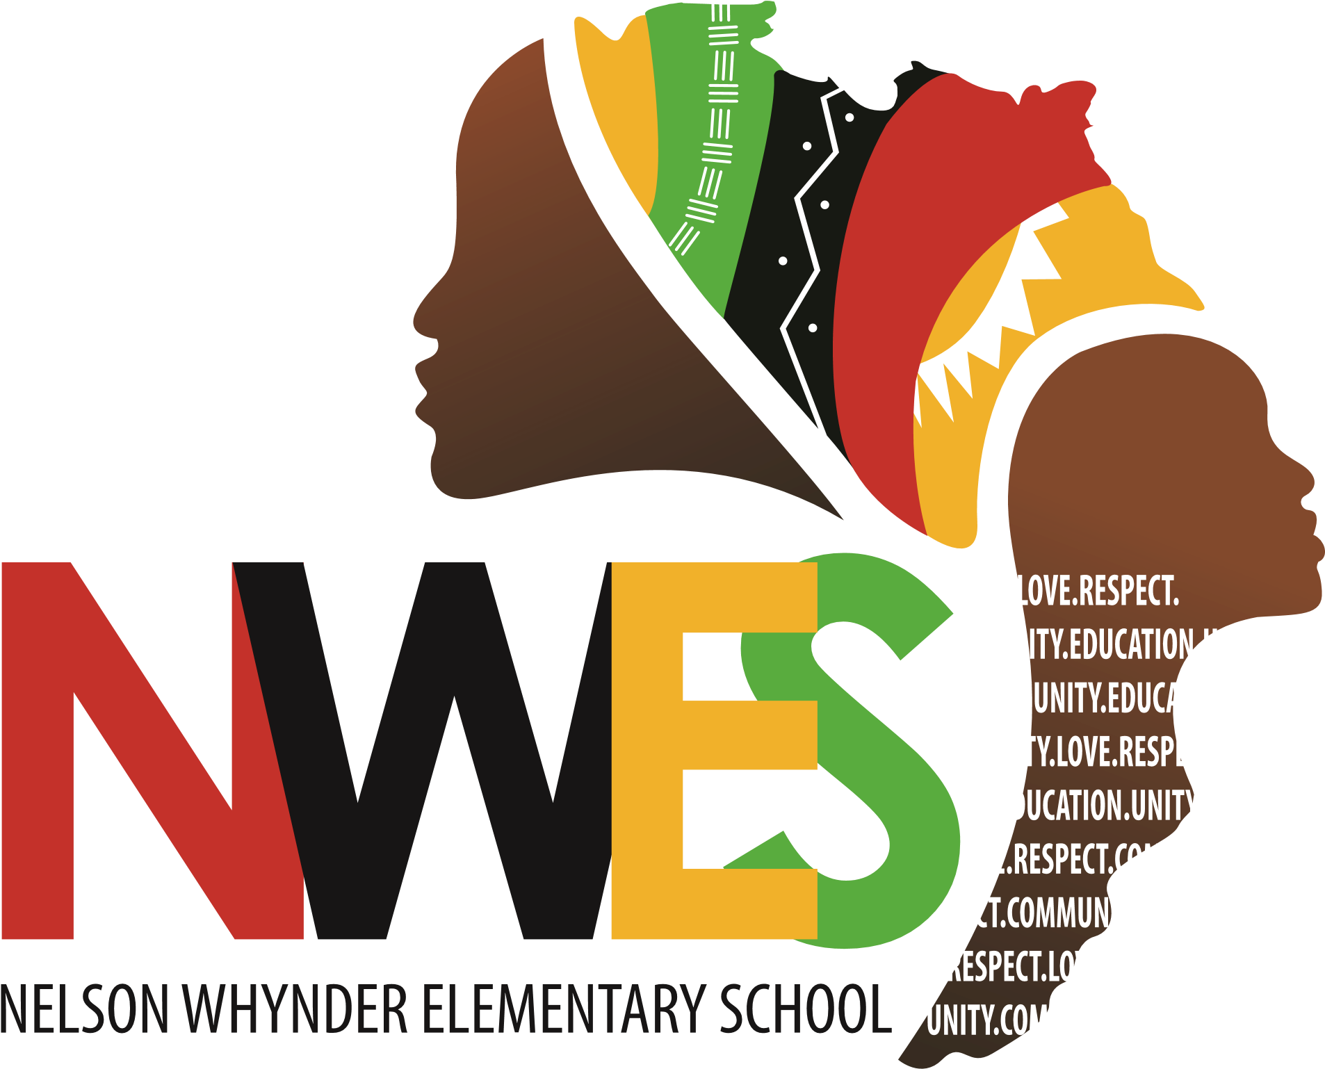

# **PRINCIPAL’S MESSAGE**

Dear NWES Families,

As we step into March, I want to take a moment to acknowledge the dedication, resilience, and teamwork that continue to make our school a place of excellence and belonging. We have accomplished so much together, and I am proud of the hard work of our students, staff, and families.

This month, we have embraced many meaningful learning opportunities in celebration of African Heritage

Month. Our students and staff were honored to experience a powerful performance by the Saint Thomas

Baptist Church BYF Youth Choir and engage in Elder Chats with Pastor Bruce Johnson, Rose Fraser, and Bishop Edward Simmonds. Special presentations by Micah Smith, Paul Ash, Alicia Kibwaa, and Karen Provo further enriched our understanding and appreciation of African heritage and contributions. We want to say thank you to all. Also, we want to express our gratitude to Chris Johnson and Rachel Ross for giving our students the opportunity to participate in the Tunnel Vision Program offered every Wednesday.

In addition, our students have been working hard in preparation for our first-ever “WHO AM I!?” Fair, an exciting event that showcases identity, culture, and self-expression. We invite families, community members, and partners to join us in celebrating our students and engaging in this journey of self-discovery and connection. It will be held on Thursday, March 6, 2025 at 1 pm in the gymnasium.

We look forward to seeing you.

Finally, as we approach the final stretch of the school year, I encourage all staff to continue fostering a culture of reflection, collaboration, and shared accountability. Together, we are making a difference in the lives of our students, and I am grateful for your dedication.

Thank you for your ongoing commitment and support.

With gratitude,

# April Desmond



## Visitors Entering the School

We warmly welcome you to our school and appreciate your involvement in our school community. For the safety and well-being of all students, we kindly request that families and visitors sign in at the office upon arrival. To ensure health and safety measures are upheld and to minimize classroom disruptions, we ask that you please wait at the office while our administrative assistant or a member of the administration assists you.



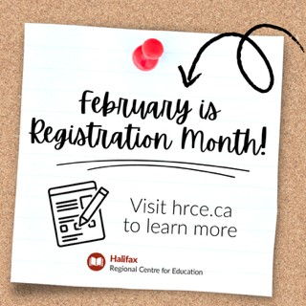**Friendly reminder if you have a pre-primary or primary child and have not registered for the 2025-2026 school year see information**

Registration for the 2025-26 school year begins on February 3. To ensure we have the right staff and support in place for September, it’s important that we gather enrolment numbers now.

Tip: Before you begin, make sure you have the following documents in electronic form (image, PDF or Word document):

* Proof of identity/age with one of the following: birth certificate, passport, immigration papers, or legal adoption papers) if you are new to the HRCE
* Proof of home address (a recently dated official government or utility document with your current address that includes your name and date, such as water bill, power bill, internet bill, home fuel bill, a tax receipt, property assessment or a mortgage contract)

Visit the [HRCE website](https://www.hrce.ca/families/student-registration-updates) for more information and to enrol your child today through PowerSchool Enrollment!

Don’t have a child to register? Maybe you know someone who does! Please help us spread the word and pass this information on to friends, neighbours or relatives who will be looking to register for the fall.

## Pre-Primary Enrollments for 2025-26 Step-by-Step guide

Enrollments for the 2025-26 school year are open. Please visit [www.hrce.ca](http://www.hrce.ca/) to complete the enrollment for your child.

Go to STUDENT REGISTRATION, verify YOUR NEIGHBOURHOOD SCHOOL, have the following documents

ready in electronic form: Proof of Identity (birth certificate, passport, immigration papers, legal adoption papers) and Proof of Address ((a recently dated official government or utility document with your current address that includes your name and date, such as water bill, power bill, internet bill, home fuel bill, a tax receipt, property assessment or a mortgage contract). Please note: a driver's license is **not** sufficient for Proof of Address!

Follow the link under READY TO PROCEED to complete your child’s/children’s registration. Only completed registrations will be processed at the school’s end.



**Safe**

**Arrival**



Safe Arrival If your child will not be attending school or will be late, it is imperative that you call the school’s safe arrival line at **1-833-582-6940** or visit https://sishrsb.ednet.ns.ca/public/ to record them as absent. The automated system will call out for all unaccounted absences. If your child will be arriving late, please record them as absent, and the office will mark them present once they have arrived at school. The automated system is not set up to account for half day absences. Daily attendance and prompt arrival at school ensure your child(ren) and all other students in the class a successful start to their day. Missing even 10 minutes of a morning routine can interrupt student learning. We encourage parents to call the safe arrival line rather than calling the school.



**Upcoming School Events**

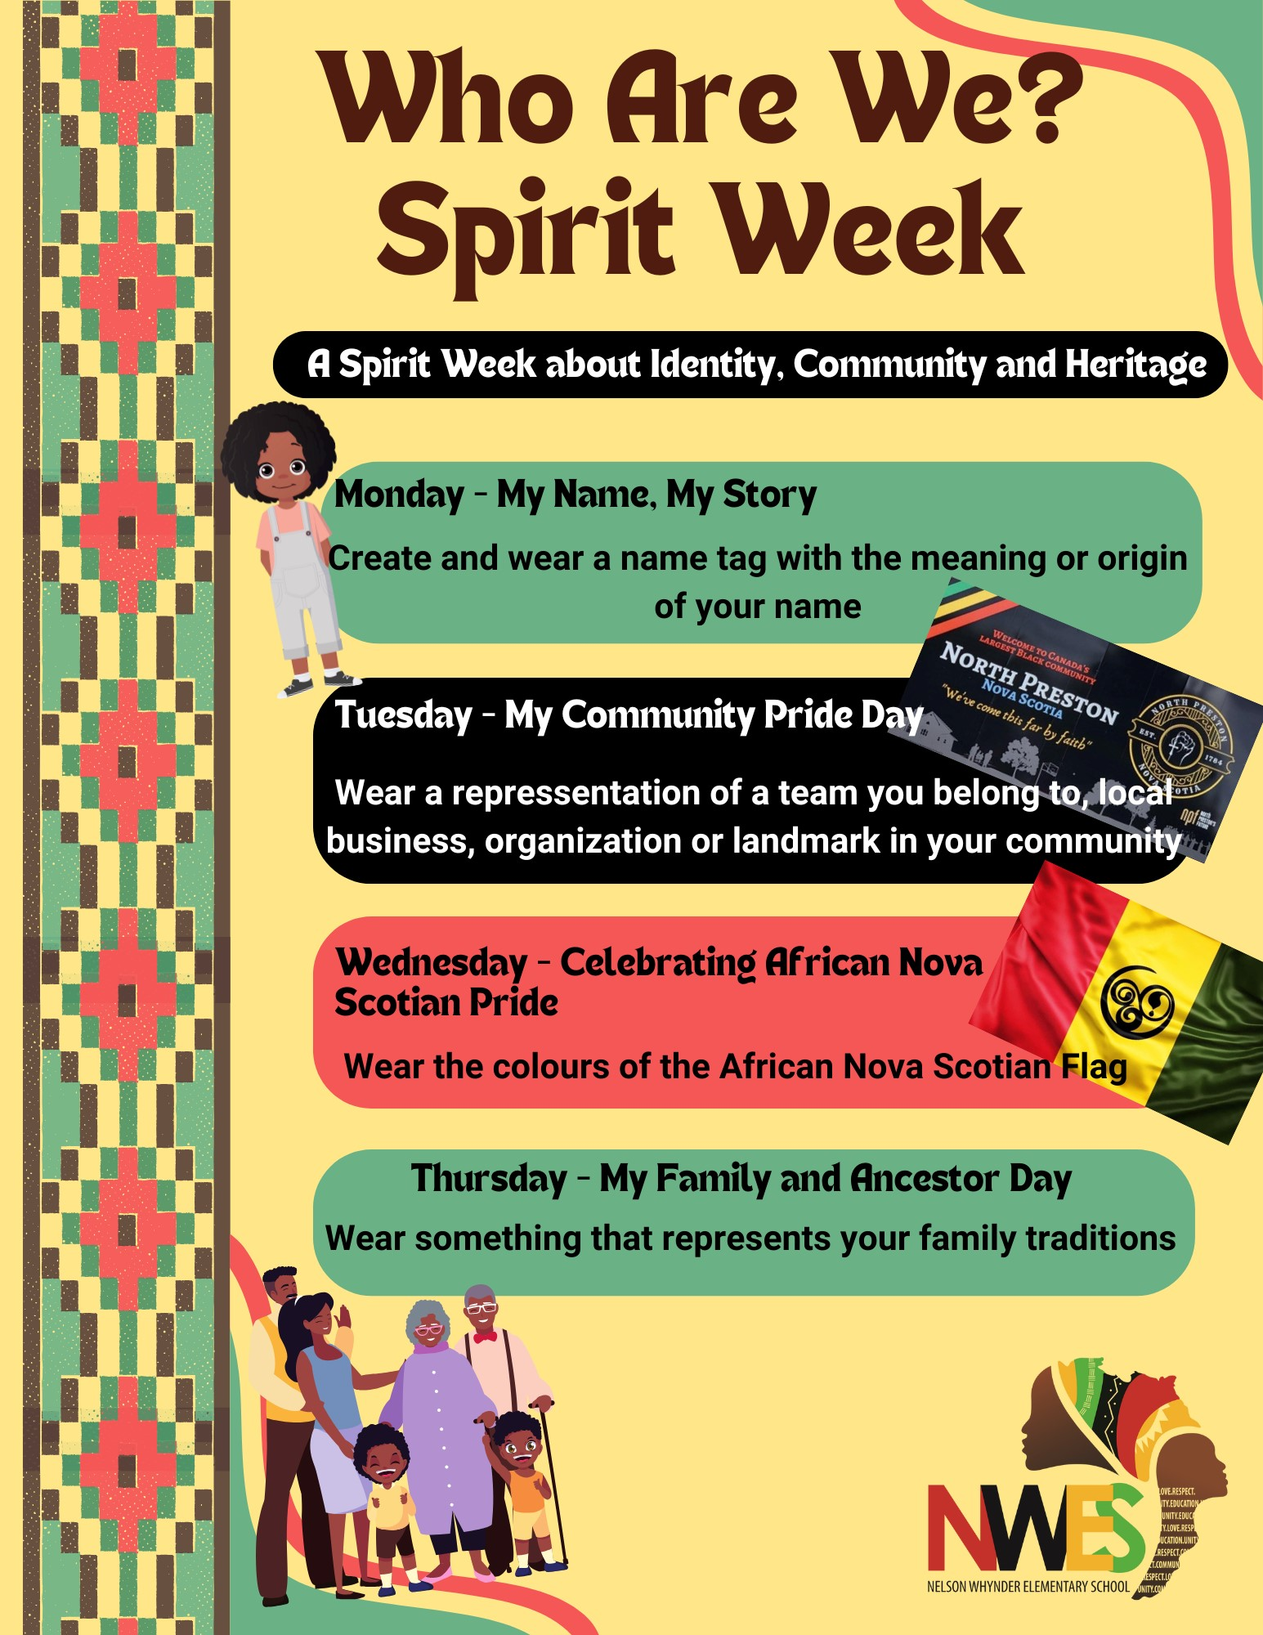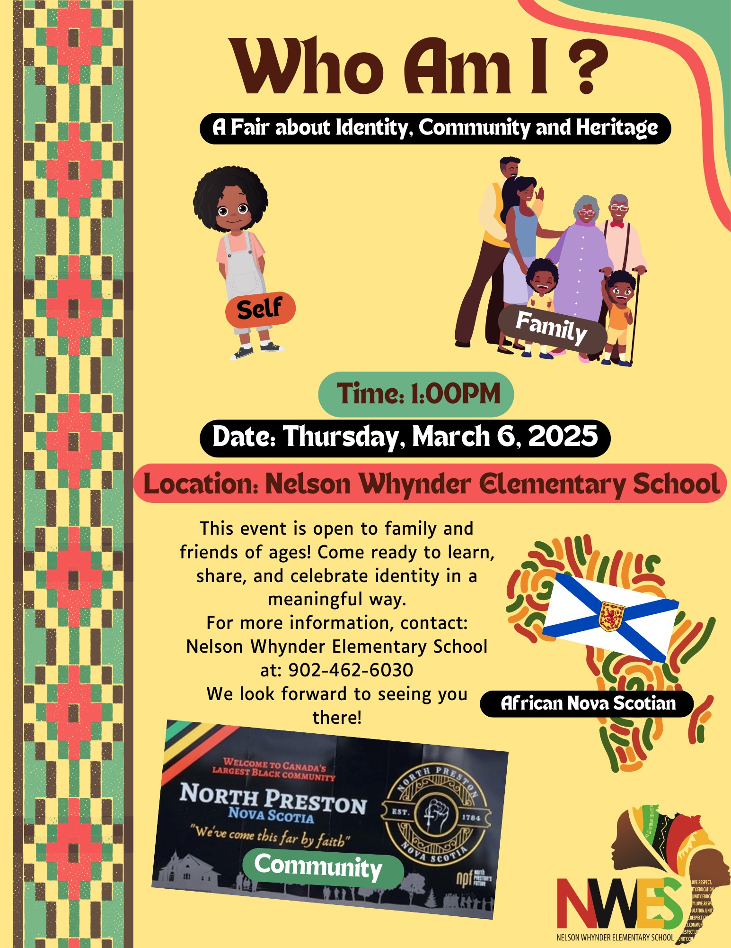

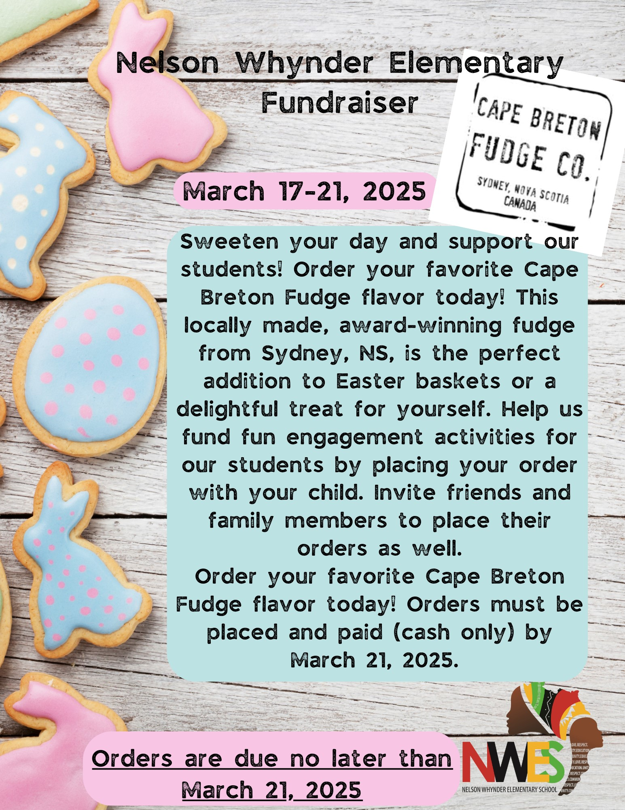

**Cape Breton Fudge Fundraiser March 17-21, 2025**

Order Forms will be sent home with students on March 17, 2025.

We encourage families to share this fundraiser with friends and family members.

**We will be able to ONLY accept CASH payments!**

We appreciate your support for our school and students.



### March is Nutrition Month

Did you know? March is Nutrition Month! This year’s theme, Nourish to Flourish, highlights the important role that food has on our physical, mental and emotional health and well-being.

Whether it’s planting an indoor or outdoor garden, cooking together with family, or enjoying a meal with friends, food provides opportunities for building social connections that can support improved feelings of belonging and overall well-being. This is a great time to explore and learn about food. An important part of this is food literacy, which includes having the knowledge and skills to grow, choose, prepare, and talk about food.



#### School Bus Safety Reminder

More than 33,000 HRCE students take the school bus. Making sure they have a safe and happy trip to and from school is very important to us. Please talk with your child about school bus safety on a regular basis. Students should tell their bus driver and/or school principal if they have any problems.

Here are some important safety tips:

#### Bus Stop Safety

* Be on time for the bus. Don't run to or from the bus.
* Stand back when the bus arrives and give everyone space. Get on or off the bus one at a time.
* Always cross the road in front of the bus. Walk to a spot where you can see the driver. When they signal it’s safe, walk to the middle of the road. STOP, LOOK, and LISTEN, then cross when it’s safe.
* Never crawl under the bus or cross the road from behind it.

#### School Bus Safety

* Respect and listen to the driver. Their job is to focus on the road, so avoid distracting them.
* Respect others and your space.
* Keep noise levels down.
* Stay seated while the bus is moving.
* Keep your arms, legs, and head inside the bus.
* Do not throw anything inside or outside the bus. ● Keep the aisle clear.

***Did you know: It's illegal for drivers to pass a school bus when it has stopped with its red lights flashing. Bus drivers will activate their amber lights 150m before they stop as a warning to motorists.***

More information about HRCE student transportation and school bus safety can be found [here](https://www.hrce.ca/families/student-transportation).



# **Lunch Monitors**

Nelson

Whynder

Elementary

School

is

looking

for

Lunch

Monitors!

If

you

are

interested,

please

contact

the

office

at

902-462-6030

Ext.

0

for

more

information,

or

come

on

in

and

ask.

Lunch

Monitors

are

required

to

provide

a

full

Criminal

Background

check,

Vulnerable

Sector

Search

and

a

Child

Abuse

Registry

to

be

considered

for

the

position.





**Dental Clinic**

**Children’s clinic:**

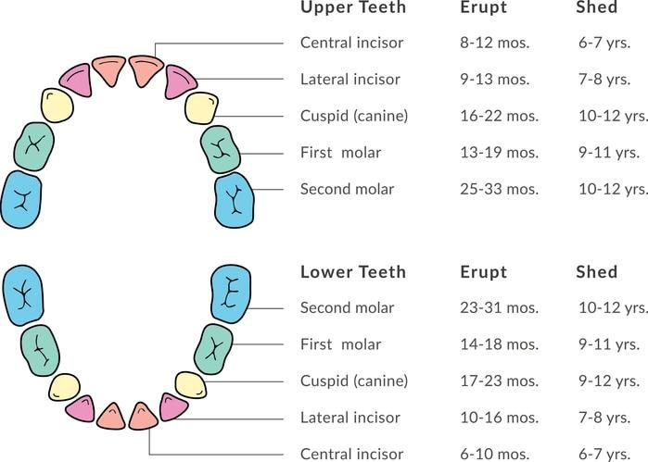The dental clinic is seeing a lot of wiggly teeth, this is very normal and they are only baby teeth making room for the permanent ones to come in.

I am including a chart that lists when they should fall out (shed) and when the new (erupt) will come in.

However, note this is only a growth chart to go by, not everyone will happen in the same order. Hope this is helpful.

If you have any questions or concerns you can contact us anytime.

**Adult’s clinic:**

We still have a few openings before closing in April, give us a call if your interested #902-462-2041.

Also, don't forget to apply online for the CDCP (Canadian Dental Care Program) to see if you're eligible for dental care.



## Positive Participation Awards

**Positive Participation Awards for the Month of February, will be announced in March! Stay tuned!**



### PHOTO GALLERY

