|  |
| --- |
| **Nelson Whynder Elementary**  **October 2024 Newsletter**  **IMPORTANT DATES:**  **• October is Mi’kmaq History Month**  **• October 1: Treaty Day(no classes)**  **• October 4: National Day of Action for Missing and Murdered Indigenous Women and Girls**  **• October 11: Professional Learning Day (no classes)**  **• October 14: Thanksgiving (no classes)**  **• October 21: SAC Meeting**  **• October 23: Picture Day**  **• October 25: NSTU Conference Day (no classes)**  **• October 31: Apple-picking Trip** |

**PRINCIPAL’S MESSAGE**

Dear NWES Families,

As we step into October, I want to take a moment to reflect on the amazing work we accomplished in September. It was a busy month filled with opportunities to build routines, get to know one another, and foster a strong sense of community within our classrooms and across the school.

We proudly celebrated **Anti-Bully Pink Day**, where students and staff stood united against bullying, reinforcing the importance of kindness and respect. We also took part in the annual **Terry Fox Run**, honoring Terry's legacy of hope and perseverance, as our school community joined in the effort to raise awareness for cancer research.

On **September 28th**, we observed **Orange Shirt Day** in remembrance of the victims of the Residential School System. Through powerful discussions and curriculum resources, teachers guided students in understanding the history and impact of residential schools, emphasizing the importance of reconciliation and the ongoing journey towards healing.

To mark **Treaty Day**, we hosted a special **"We Are All Treaty People" Assembly**, where an elder from the Mi'kmaq community, along with special guests, led various activities. These activities offered students a deeper understanding of **Mi'kmaw culture and heritage**, emphasizing our shared responsibility in honoring the treaties and fostering respect for the rich traditions of the Mi’kmaq people.

Here at Nelson Whynder, we are committed to creating a safe and inclusive environment where every student can learn and grow. Below you will find our commitment statements of how we are ensuring that our school is a safe and inclusive space for each student, staff and our visitors.

**Our Commitment to a Safe and Inclusive Learning Environment:**

* We believe in setting clear expectations for behavior to ensure that our school is a place where everyone feels safe and respected.
* Our approach focuses on preventing unsafe incidents before they happen and addressing them quickly if they do.
* We prioritize the safety and well-being of all students, staff, and families in every decision we make.
* If a student makes a mistake, we will work with them to help them learn from it and find better ways to handle similar situations in the future.
* Whenever possible, we use restorative practices that help heal and build a stronger community after conflicts arise.
* We will always strive to keep students in class and learning, but if a student needs to be removed for safety reasons, we will ensure they receive the support they need.

The Nova Scotia **Provincial School Code of Conduct Policy** outlines the expectations for behavior in our school to ensure a safe, inclusive, and supportive learning environment. It applies to all students, staff, and visitors, emphasizing respect, responsibility, and safety. If you would like to view this document please click the following link. [Provincial School Code of Conduct Policy](https://www.ednet.ns.ca/docs/provincialschoolcodeofconduct.pdf)

We will implement the school code of conduct when students are exhibiting behaviors that are not conducive to providing a safe learning environment.

Thank you for your continued support and dedication to making Nelson Whynder School a place where every student feels valued and empowered.

Warm regards,

April Desmond

**School Bus Safety Week**

October 21-25, 2024 is School Bus Safety Week in Nova Scotia!

Did you know that more than 30,000 HRCE students ride the school bus every day?

School Bus Safety Week is a great time to remind students, families and schools of a few daily safety tips that everyone can follow to ensure all students get to school safely.

***Bus Stop Safety***

* Be on time for the bus and please don’t run to/from the bus.
* Stand back off the road and don't push or shove when waiting at a stop.
* Always cross in front of the bus. Walk three metres (10 feet) in front of the bus to a point where you can see the driver and wait for the driver's signal to cross. Proceed to the centre of the road, STOP, LOOK & LISTEN and cross the road when it is safe.
* Never crawl under a school bus or cross the road behind the bus.
* Know the danger zones around the bus.

***School Bus Safety***

* Please respect and listen to the driver and avoid distracting them.
* Please keep noise levels to a minimum.
* Do not stand or move seats while the bus is in motion.
* Never put your hands, arms, feet or head out of the bus window.
* Ask the driver for permission before you open the bus windows.
* Do not throw anything inside the bus or out of the windows.
* Always keep the aisle clear when the bus is in motion.

You can find out more information about School Bus Safety Week, including more safety tips, [here](https://www.schoolbussafety.ca/kids).

**Positive Participation Awards**

The NWES Positive Participation Awards will begin this month with a focus on the character traits outlined in the student creed. It sounds like a great initiative to promote positive behavior and character development!

**I am student seeking to be a scholar**

**The standard is excellence today and tomorrow**

**I am disciplined, focused, and on-time**

**I am organized respectful and responsible**

**I am on a mission to elevate myself, my family, my community, and humanity.**

**By: Chike Akua**

**School Pictures**

Student Pictures School pictures will be taken on Wednesday, October 23rd 2024. Retakes will be on Thursday, November 28th. Parents are to closely review the options for ordering. The purchase of school pictures is, of course, optional.

**Lunch Monitors**

We are currently recruiting for Lunch monitors. Lunch monitors provide support and assistance to students during lunch time activities under the direction of the school principal. The lunch monitor will oversee students in a variety of settings in the classroom, lunch area, and outside play. Please contact the school office at 902-462-3060 if you or someone you know may be interested in a position. This is a paid position.

**Registration/Demographic Updates 2024-2025**

Please ensure you update your Demographic Form. Additionally, this form will include the integration of the “Publication of Student Personal Information and Student Work” form that is required to be updated yearly.

**Safe Arrival**

Safe Arrival If your child will not be attending school or will be late, it is imperative that you call the school’s safe arrival line at 1-833-582-6940 or visit https://sishrsb.ednet.ns.ca/public/ to record them as absent. The automated system will call out for all unaccounted absences. If your child will be arriving late, please record them as absent, and the office will mark them present once they have arrived at school. The automated system is not set up to account for half day absences. Daily attendance and prompt arrival at school ensure your child(ren) and all other students in the class a successful start to their day. Missing even 10 minutes of a morning routine can interrupt student learning. We encourage parents to call the safe arrival line rather than calling the school.

**What is SchoolsPlus?**

SchoolsPlus is a confidential, free service available in every school in Nova Scotia. Our goal is to build positive relationships between families, schools, and communities. We can help families navigate complicated situations when they are involved with many different services. This helps ensure everyone is communicating clearly and working on shared goals. SchoolsPlus can also help connect families to community resources and offer mental health support in schools. Contact the SchoolsPlus Facilitator for your school to make a referral. You can find additional information [here](https://www.hrce.ca/students/student-services/schoolsplus).



**Nova Scotia School Lunch Program**

The NS School Lunch Program is just around the corner. In anticipation of its launch, we would like to provide you with the link so that you can familiarize yourself with the site, read the FAQs, and take a look at the upcoming menu. <https://nslunch.ca/>

Ordering will open on Friday October 18th, at which time families will be able to login and order meals. The first day of the program will be on Monday October 28th.

Here is a link put out by the EECD with a step by step guide to logging in and ordering. <https://www.youtube.com/watch?v=j_z25C_3YBs>

#### Mi’kmaw History Month

#### Theme: Food and its significance in Mi’kmaw culture

Food gathers us together for celebration, nourishment and comfort. It is central to our ceremonies, considered part of our medicines, and key to our resiliency. Sharing freely honours each other and blesses our families and communities so no one is harmed or struggles. The long-ago treaties with the first plants and animals of Mi’kma’ki require us to love and to protect msɨt no’kmaq (all our relations). Living through the values and ways of netukulimk over thousands of years has carried our communities through times of abundance and scarcity.

Water is life! Our cultural practices protect the shorelines, estuaries, and aquatic habitats, where so much of our food is harvested. This protection is extraordinarily important to the ongoing treaty relationships among all living beings in Mi’kma’ki.

**DENTAL CLINIC NEWS**

Dear Parents/Guardians.

Just a friendly reminder to check your child (s) school bags for any consent’s forms that need returning or information from the dental clinic.

Also, adult care is on Tuesday afternoon, for any Preston resident that does not have a dentist or dental insurance and would like to have an assessment and cleaning done.

**FYI**: Snacks play a very important role in dental health. I am sending home a booklet called Good Habits Starts Early. We all know Early Prevention is the Best Prevention….. Please take some time over dinner or during bedtime to read/discuss healthy eating options that will help in protecting your child’s teeth from getting cavities.

If you have any questions, concerns or suggestions that you would like for us to address, please don’t hesitate to reach out. Clinic number **#902-462-2041**

**PHOTO GALLERY**

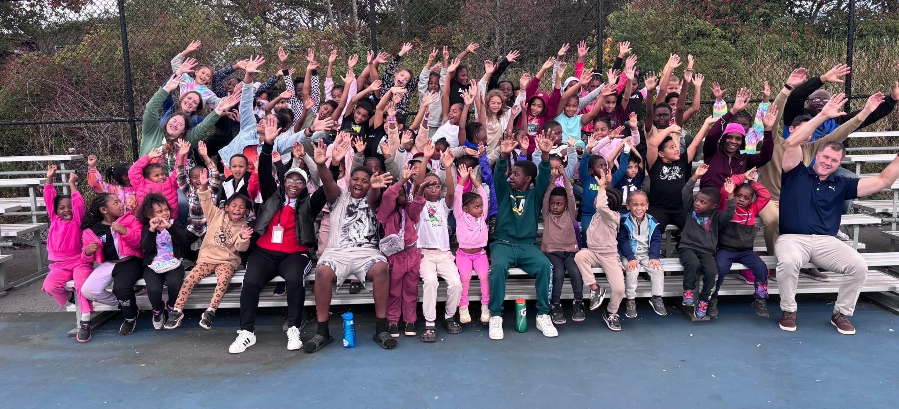

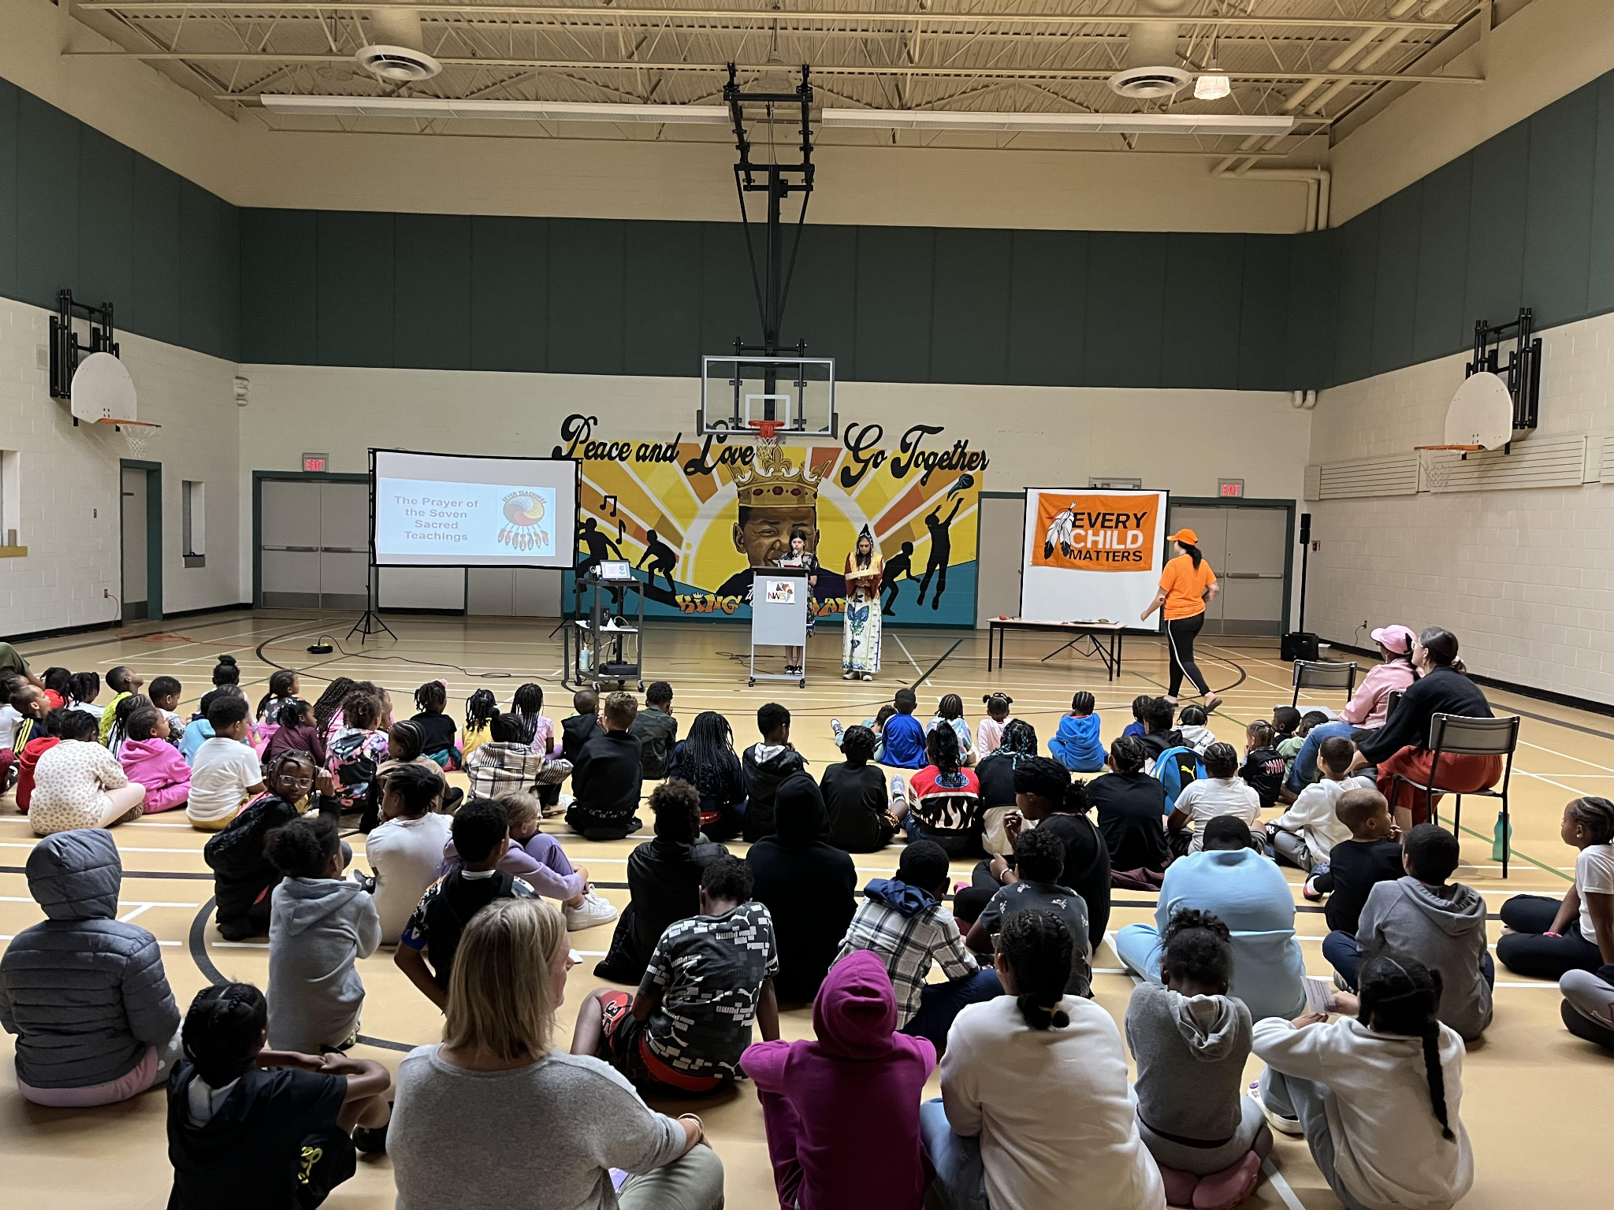

We are moving to sending out our newsletter electronically through School Messenger. Please sign below and return this form to the school, indicating that you would like to receive a hard copy.

___ Yes, I would like a hard copy of the newsletter.

**Student's Name:** _________________________

**Parent/Guardian's Name:** _________________________

**Signature:** _________________________

**Date:** _________________________