|  |
| --- |
| **Nelson Whynder Elementary**  **November 2024 Newsletter**  **IMPORTANT DATES:**   * **November 8: Indigenous Veterans Day** * **November 8: School Remembrance Day Ceremony** * **November 11: Remembrance Day (no classes)** * **November 15: World Drummer by Goat Works Presentation** * **November 20: Transgender Day of Remembrance** * **November 22: Assessment & Evaluation Day (no classes)** * **November 28: Picture Retake** |

**PRINCIPAL’S MESSAGE**

Dear NWES Families,

As we embrace the new month, I want to take a moment to reflect on October’s events and share what’s coming up for November.

In October, we came together as a school to honor Mi’kmaw heritage and culture, learning more about the rich traditions and values of the Mi’Kmaw community.

We are excited to welcome Biba Lebel as our new administrative assistant and Jean Cain as our new Primary/Grade 1 classroom teacher! We are delighted to have them both as part of our team.

I would also like to extend a heartfelt thank you to Pastor Smith, our guest speaker at the October Student Celebration Assembly. His inspiring words about our Student Creed resonated deeply, reinforcing the values we aim to uphold here at NWES.

Thank you, families, for your support in the successful rollout of the NS Lunch Program. Please reach out to the school, if we can be of any assistance with the program.

We also want to thank Constable Riley from the North Preston RCMP Detachment for visiting and presenting on Halloween safety. The students enjoyed learning valuable tips for staying safe, and Constable Riley’s treats were a big hit!

Another highlight was our school-wide trip to Noggin Farms. We were lucky to have a beautiful day, and the students thoroughly enjoyed picking apples and bringing home their own bags to share with their families.

As we look ahead, we have some important events on our November calendar. On November 8, we will honor Indigenous Veterans Day, and we invite students to join us in a spirit of respect and remembrance during our school’s Remembrance Day ceremony on the same day. This is an opportunity to reflect on the sacrifices made by veterans, both past and present. The school will be closed on November 11 in observance of Remembrance Day.

Please also note that November 22, 2024, is Assessment & Evaluation Day, so there will be no school for students.

Thank you for your continued partnership and support in making our school a warm and welcoming place for everyone.

Warm regards,  
 April Desmond



**Photo Retake Date**

Families, if you would like to have your child’s photo retaken. NWES retakes are on **November 28, 2024.**



**Demographics Update Form**

Please make sure to complete the Demographics Update Form by November 20, 2024. It is very important to look over the contact information provided to the school as well as resign the Media Consent Form.

Log in your parent portal account with your email, if you don’t recall your password you may reset it with the “forgot password” function.

<https://sishrsb.ednet.ns.ca/public/>



**Lunch Monitors**

Nelson Whynder Elementary School is looking for Lunch Monitors! If you are interested, please contact the office at 902-462-6030 Ext. 0 for more information, or come on in and ask.

Lunch Monitors are required to provide a full Criminal Background check, Vulnerable Sector Search and a Child Abuse Registry to be considered for the position.



**Inclement Weather**

Did you know? HRCE takes great care when making the decision to alter the regular operations of schools and school buses in the event of severe or inclement weather. Please make sure your child/children are dressed for the weather.

It is HRCE’s goal to communicate any changes to the regular operations of schools and/or buses as close to 6:00 a.m. as possible. **A 6:00 a.m. announcement could be:**

· All schools are delayed in opening by two hours and bus pickups are delayed by two hours; or

· All schools are open, but some or all busses are not operating for the day; or

· Some schools (either individually or by family) are closed for the day; or

· All schools are closed for the day.

If weather deteriorates, or is forecasted to worsen throughout the morning, **an 11:00 a.m. announcement could be:**

· Bussed students will be picked up two hours earlier than their regular dismissal time; and

· Walking students will be dismissed at their regularly scheduled lunch hour.

**How will I find out?**

· By email to the addresses in PowerSchool

· By text message, **if you have opted-in**. If you aren’t sure if you have opted-in, text Y to the following number: **978338**

· [On the HRCE website](https://www.hrce.ca/)

· [On X (formerly Twitter)](https://x.com/HRCE_NS)

· [On Instagram](https://www.instagram.com/hrce_ns/)

It’s important to always have a plan in place for childcare in the event of any cancellation.

For more information on how HRCE manages during inclement weather, visit [hrce.ca/weather](https://www.hrce.ca/weather).



**Indigenous Veterans Day**

Indigenous Veterans Day, observed on November 8, acknowledges the unique

contributions and sacrifices made by Indigenous soldiers. This day highlights the bravery

and commitment of Indigenous veterans, who have served with distinction despite facing

historical and ongoing challenges**.**

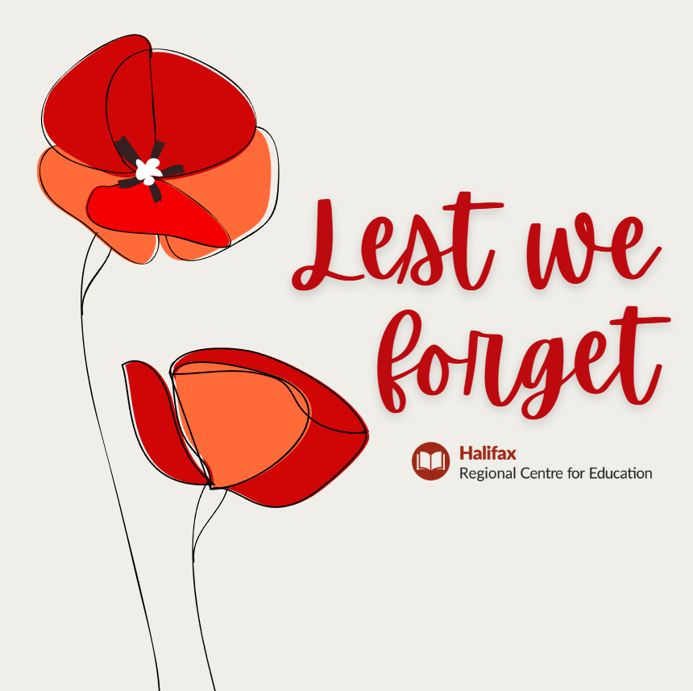

**Remembrance Day**

Every year on November 11, we observe Remembrance Day to commemorate the

sacrifices of the armed forces during World War I, World War II, and other conflicts.

This solemn day is marked by ceremonies, moments of silence, and the wearing of

poppies in honour of those who have served and fallen.

Together, these days remind us of the courage and resilience of all who have served.



**Transgender Awareness Week**

Transgender Awareness Week, observed in the second week of November, focuses on raising awareness about the issues facing transgender and gender non-conforming individuals. The week highlights the challenges transgender people face, such as discrimination and lack of healthcare access, and promotes acceptance and inclusivity by encouraging supportive policies and practices.

The week helps to foster solidarity within the transgender community and with allies, providing emotional support and strengthening the transgender movement. It culminates in the Transgender Day of Remembrance on November 20, a day to honour those lost to anti-transgender violence, emphasizing the need for continued protection and support. 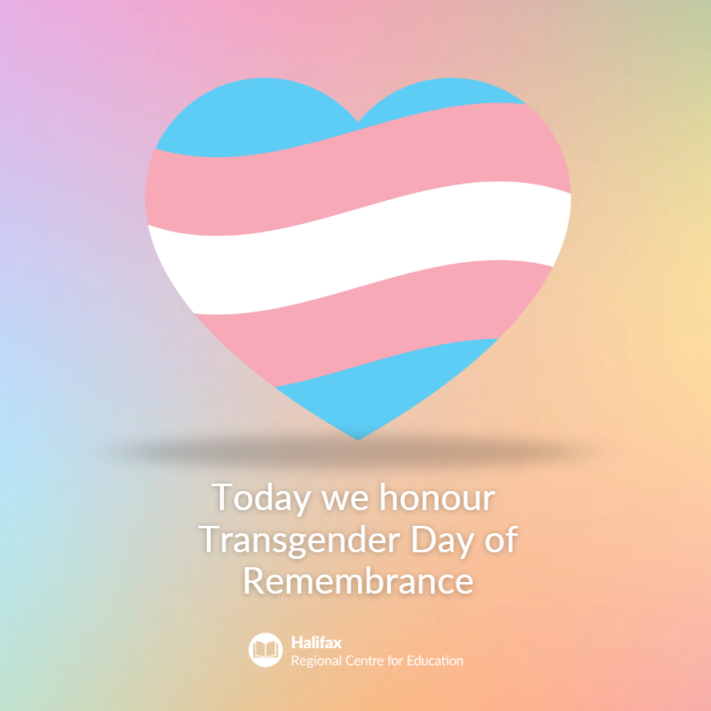

**Be an ally**

An ally is someone who actively and consistently supports, stands with and advocates

for the 2SLGBTQIA+ communities. The best way to be an ally is to listen with an open

mind. It is our responsibility to treat all people with dignity and kindness.

 **Nelson Whynder Santa’s Workshop**

Students will have the opportunity to shop for their loved ones at our Christmas Santa Shop on

**Wednesday, December 18th, 2024**. Proceeds from the sale will be used as a school fundraiser.

The school will be accepting donations of new or gently used items. We are also looking for donations of

wrapping paper, gift bags and tags. Donations can be delivered to the school between **Monday, December 2 to Friday, December 6h, 2024.** 

Please contact the school at 902-462-6030 for more information.



**Safe Arrival**

Safe Arrival If your child will not be attending school or will be late, it is imperative that you call the school’s safe arrival line at 1-833-582-6940 or visit https://sishrsb.ednet.ns.ca/public/ to record them as absent. The automated system will call out for all unaccounted absences. If your child will be arriving late, please record them as absent, and the office will mark them present once they have arrived at school. The automated system is not set up to account for half day absences. Daily attendance and prompt arrival at school ensure your child(ren) and all other students in the class a successful start to their day. Missing even 10 minutes of a morning routine can interrupt student learning. We encourage parents to call the safe arrival line rather than calling the school.



**Positive Participation Awards**

**Positive Participation Awards for the Month of September and October :**

|  |  |  |
| --- | --- | --- |
| **Classroom Awards**  **Pre Primary:** **Kazaya Bundy, Ahmyus Downey**  **Primary/One: Ka’Niayah Beals, Azayla White**  **Grade One/Two: Alijah Smith, Nevaeh Simmonds**  **Grade Three/Four: Aleciah Cain, Dayvon Flint**  **Grade Four/Five: Carter Shearer, Tyler Cain**  **Grade Five/Six: JulMyree Provo, Felicity Beals** | **Music**  **Primary: Kehlani Glasgow-Beals**  **Grade One: Heaven Downey, Novah Downey, Natanyah Rodriques**  **Grade Three:** **Fredrico Conrod**  **Grade Four: Lavonia Beals, Elayce Clayton**  **Grade Five: Carter Shearer, Lucius Fourgnaud, Julmyree Provo**  Website  Description automatically generated | **Phys.Ed.**  **Primary: Ma’Kai Cunningham**  **Grade One: Ka’Niayah Beals, Nalah Willis-Grant, Amaris Simmonds**  **Grade Three: Nai’Ondre Smith**  **Grade Four: Tre’Laina Downey, Lynaell Smith**  **Grade Five: Carter Shearer, Lynajiah Smith**  **Grade Six: Ju’Kyree Beals**  **French**  **Grade Four: Ka’Myrah Beals**  **Grade Five: Lynajiah Smith, Tyricco Freel, JulMyree Provo** |



**Home and School Organization**

We are excited to announce the formation of a new **Home and School Organization** at Nelson Whynder

School, formerly known as the Parent Teacher Organization (PTO). This initiative aims to strengthen the partnership between families and our school, creating a supportive and engaged community that works together to enhance the educational experience for all students. Joining the Home and School Organization is a wonderful opportunity for parents, guardians, and community members to collaborate with staff on various fundraising projects, events, and school initiatives that support our students’ growth and well-being.

If you're interested in being part of this dynamic team or learning more, please reach out. We’d love to have you involved!

Please contact the school at 902-462-6030 Ext. 0 for more information and to volunteer.

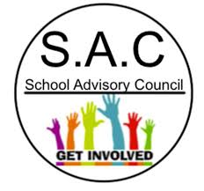

**School Advisory Committee**

We are excited to announce that Nelson Whynder School is seeking new members for our School Advisory Committee

(SAC)! The SAC plays a vital role in helping shape school priorities, fostering a positive learning environment, and supporting the success and well-being of our students.

If you’re interested in contributing to our school community, bringing forward ideas, and collaborating to make a meaningful impact, we encourage you to get involved. This is a wonderful opportunity for parents, guardians, community members, and staff to work together to support the school's vision and goals.

For more information or to express your interest, please contact us at 902-462-6030. We look forward to welcoming new voices and perspectives to our team!



**DENTAL CLINIC NEWS**

Dear Parents/Guardians.

Great job keeping up the dental hygiene with the children. Remember, with Halloween and Christmas there will be lots of sugar going into your children’s mouths. Make sure they keep brushing their teeth 2x a day. Morning and Evening.



**PHOTO GALLERY**

